JAVA

VARIABLES

DATATYPE

TYPECASTING

CLASS

OBJECT

CONSTRUCTORS

METHODS

OBJECT CREATIONS

OVERLOADING

OVERRIDING

ABSTRACT CLASS

INTERFACE

Java -> jdbs(specification) -> just an interface -> implementation of that interface - driver to connect to diff databases we use diff drivers

PACKAGES

EXCEPTION HANDLING

COLLECTION FRAMEWORK - TYPESAFETY, LIST,SET,MAP,STREAM API,

STRING HANDLING - STRING, STRINGBUILDER, STRINGBUFFER, STRINGTOKENSIZER

ADVANCE ->

J2EE

SERVELET

JSP

FILTER

DATABASE - JDDC, HIBERNATE,

SPRING FRAMEWORK ->

Losse coupling with dependency framework and inversion of control

CORE

SPRING JDBC/ORM/MVC

What prb spring jdbc solves

How spring works

Crud operation

# EXTRAS

1.

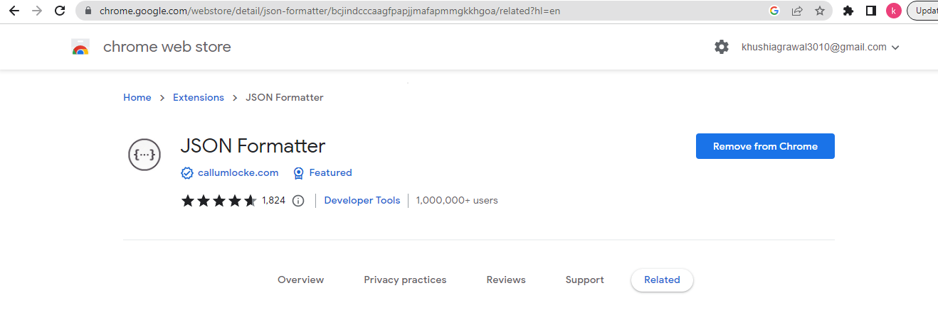

2.

<dependency>

<groupId>org.springframework.boot</groupId>

<artifactId>spring-boot-devtools</artifactId>

<scope>runtime</scope>

<optional>true</optional>

</dependency>

3. ECLIPSE SUGGESTION LIKE INTELLIGE

Usually - ctrl + space -> for suggestion in eclipse

Or

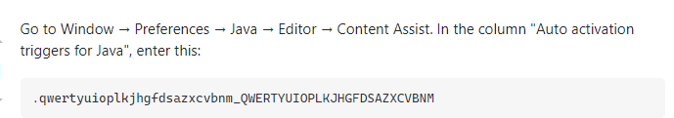

4. Ctrl+Shift +T to get enter class name to open the class

Can be used to get package

# 3rd NOV

1. Domain

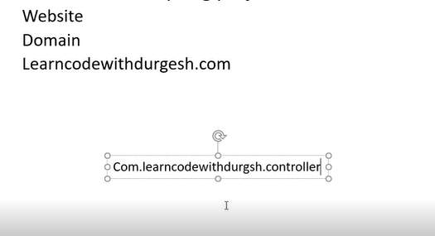

1. Prj ->

File - new - other - maven project - next - next -> select an archetype - catalog -internal -> maven archetype quickstart

Group id - kinda like package

Artifact id -

Test case -> debug as Junit

1. To get all dependencies -> Spring core maven website

<https://mvnrepository.com/artifact/org.springframework/spring-core>

Spring core

Spring context

1. DEPENDENCY INJECTION

We want code to be less coupled and dynamically changeable

We use interface for that

5.

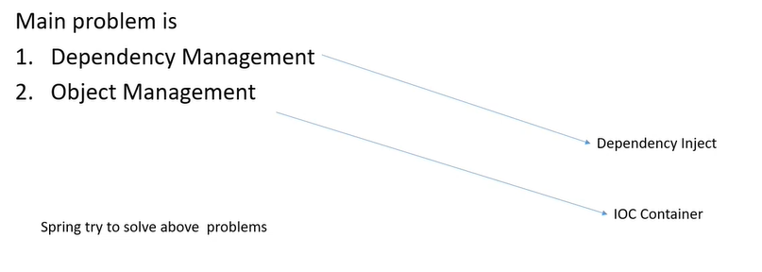

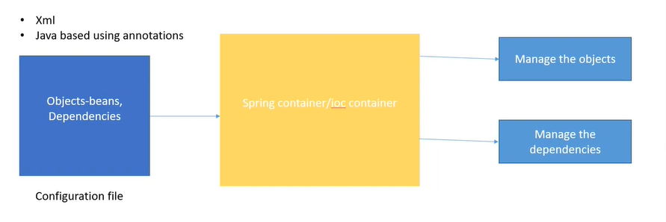

Till now we were creating objects on our own but now we have given this control to spring i.e. inversion of control.

6. To make this configuration file to give spring the objects and dependencies

Can make it in any folder in main

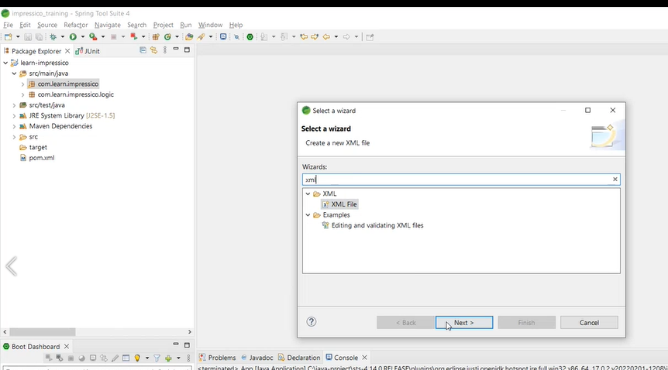

Just create a new file of type xml

So in this xml file we have to write our objects and dependencies

So inside the xml file we have the syntax of ->

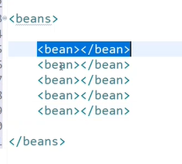

So every bean indicates a diff class for which spring has to manage its object

So we would be needing some schemas to add before this

Spring file config xml - website

<https://docs.spring.io/spring-framework/docs/4.2.x/spring-framework-reference/html/xsd-configuration.html>

From this we will use

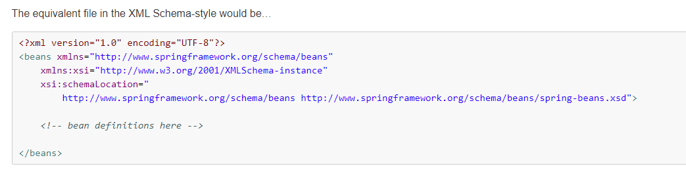

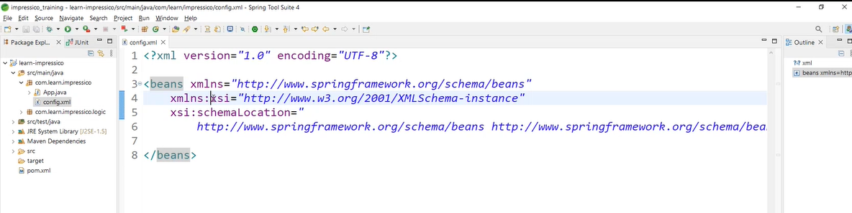

Ctrl +shift +F is for formatting

Manage that class object

We will write all the dependencies of jatin class. So here its using sort class

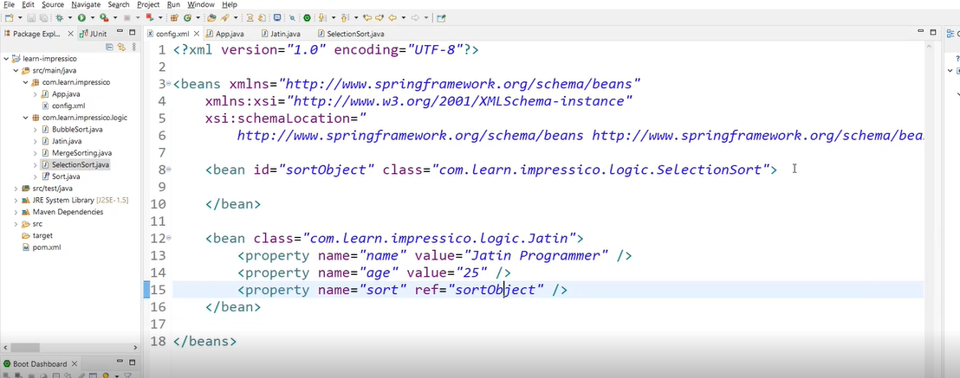

So we have property tag to define the dependency

So its diff for primitive data types and object

So here sort is an object we created in class jatin and we want it to refer selection sort so we made a bean for that class and referred it and that class wasnt dependent on anything so no property

SO now we dont really have to create object or dependencies we can just use them

So we can get all these in the container

To access the container ->

ApplicationContext interface works as our container

We will use that child that deals with xml file

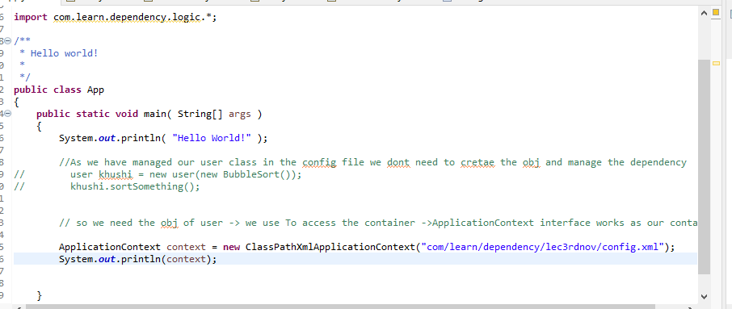

Using this context variable we can access all the objects that are written in the config file

As its facing some problem trying to create bean - we can provide getters and setters in the user class for that

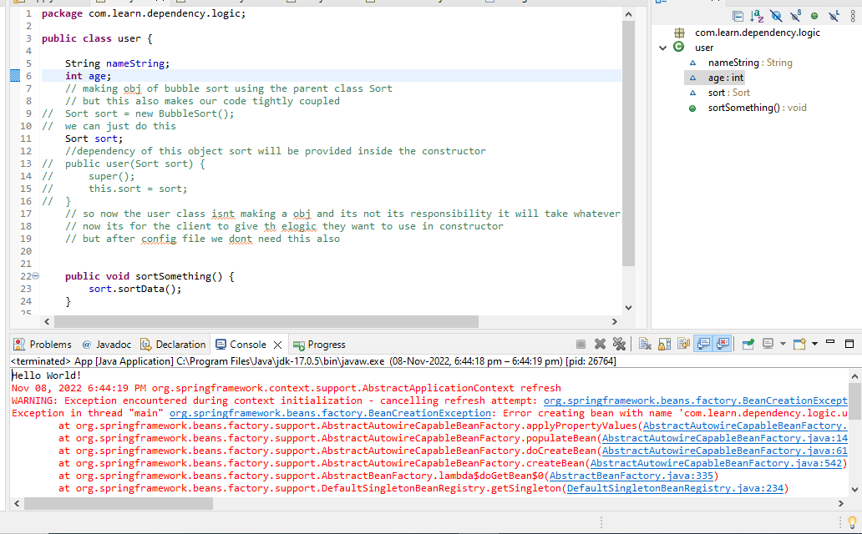

We get this output

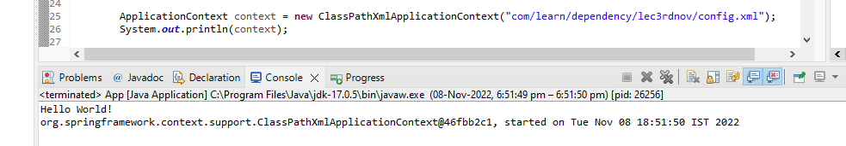

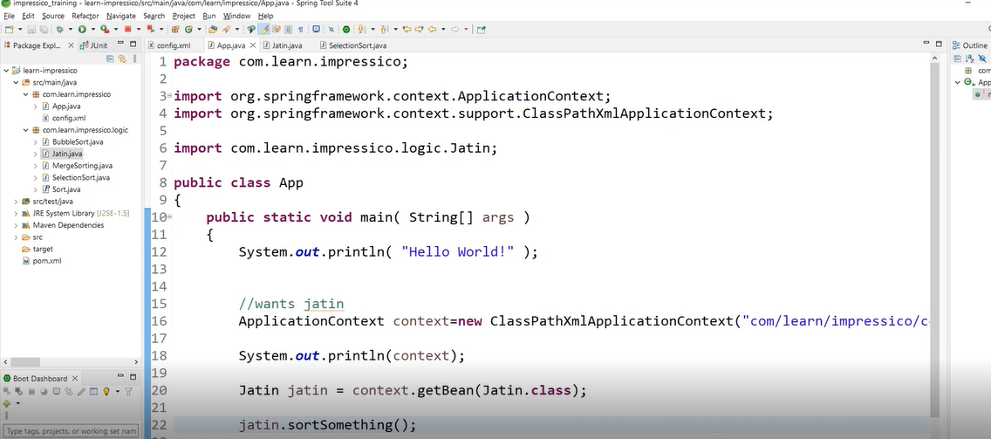

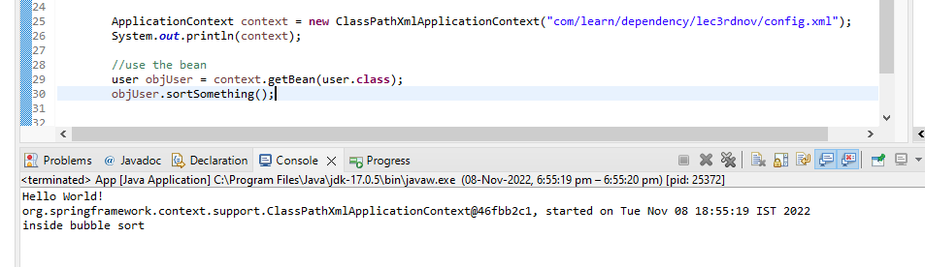

Gives bubble sort implementation because thats what we have passed as reference for sort obj in config file

So now if we want to change something we can just change in config file

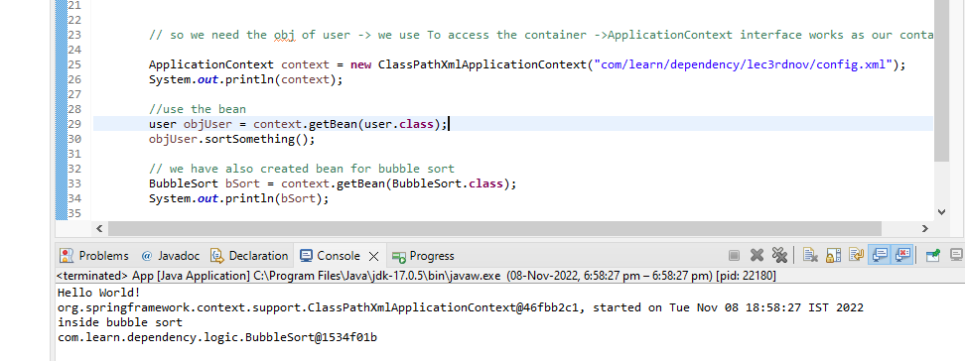

## DONE —----TO DO -> DI, CODE

# 4TH NOV

1. So previously we were getting an error when we werent putting getter and setter thats because if we see its uses default constructor to create an obj

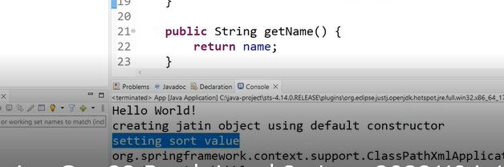

1. We have diff types of dependencies

Primitive or obj etc

For eg for these

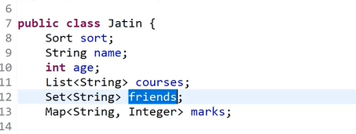

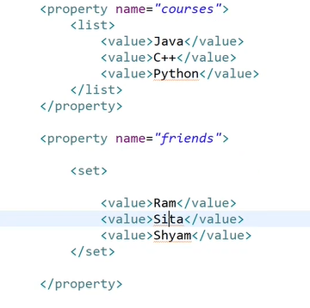,

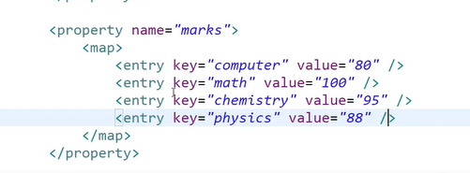

We would also have to create getters and setters of the same

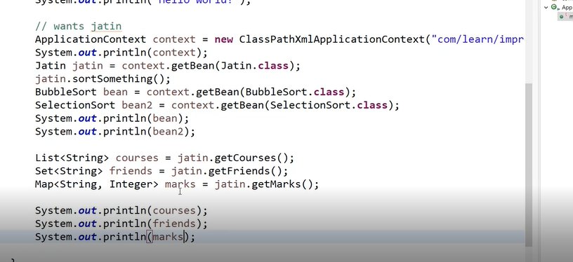

1. Even if its a private constructor then also it will run
2. We have to store list of references instead of list of string like previously



So instead of value in the list we can pass ref of the bean and it will contain the id of that bean

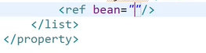

1. We can have multiple config also

We have this method that takes var no of files

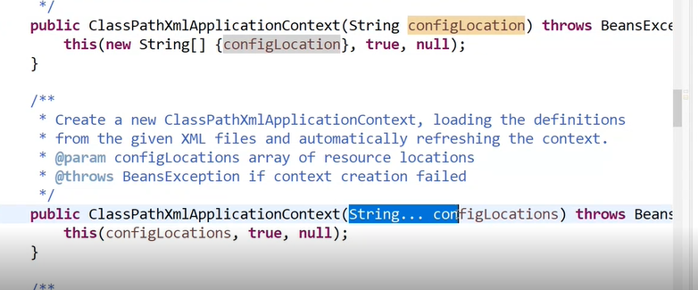

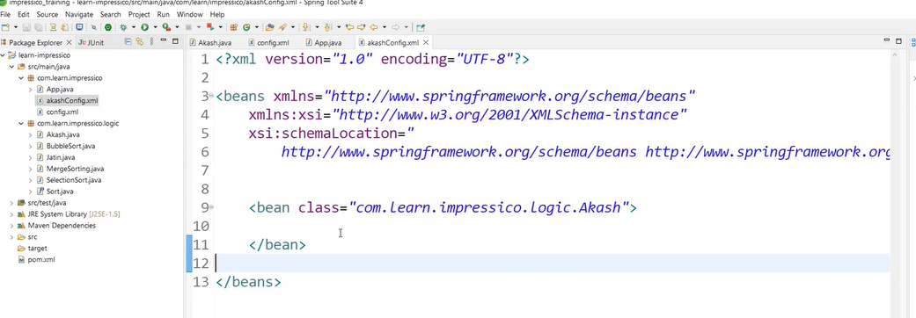

1. Injection using the paramerised constructor

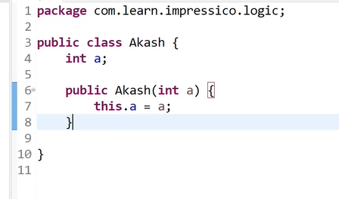

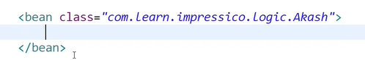

The prb is that this class doeant have default constructor or getter and setter

So we have to use the parametirised constructor to create the obj

In order to call the constructor we use

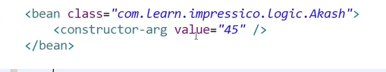

So we passed the argument of the constructor

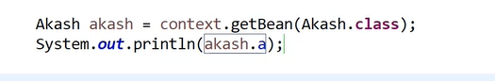

Also we have both the config files

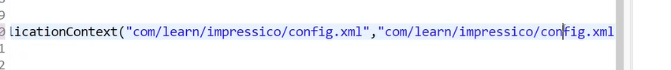

1. Auto configuration

So bvasically we r creating multiple beans and also specifying their dependencies in the config file

So have something called -> autowiring

If the bean have only one implementation

Like for our sort class if the only implementation present is bubblesort then so it doesnt confuse btw multiple

Autowire could be byname and by type

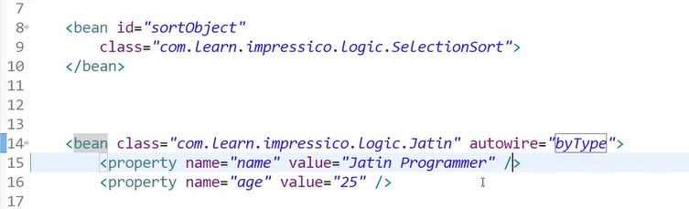

Check the dependency type

Like its of type sort

So do we have any obj of type sort

Determined on runtime

1. NEW PRJ - WHERE WE WILL BE USING JAVA ANNOTATION FOR CONFIG

In java -> we make a class for the config file

To make it a configuration file we use annotation ->

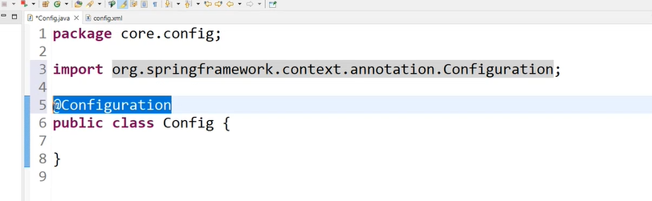

Student class ->

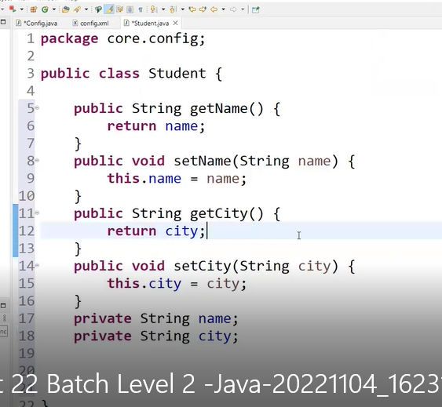

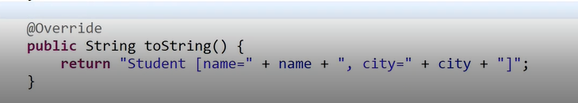

So we create a bean of this student class

We use annotation ->

@Bean

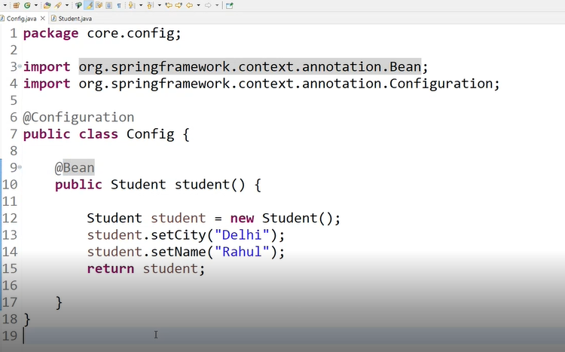

Same way in the main file we will

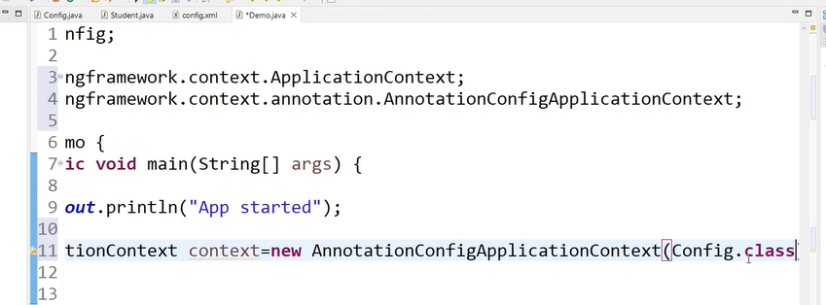

1. @Autowire

Lets say student class is using an obj of address class

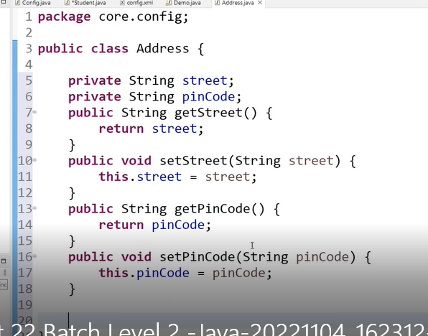

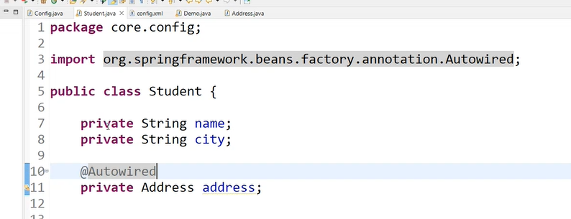

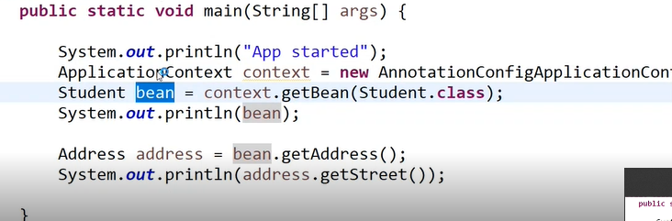

But this wont work we would have to create a bean of address class also

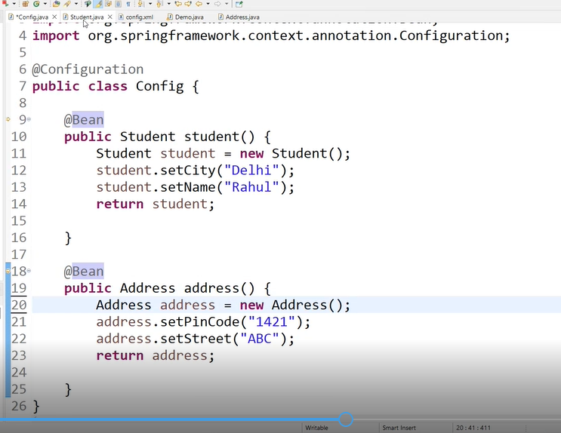

1. (We make another class which hass studnet class as dependency

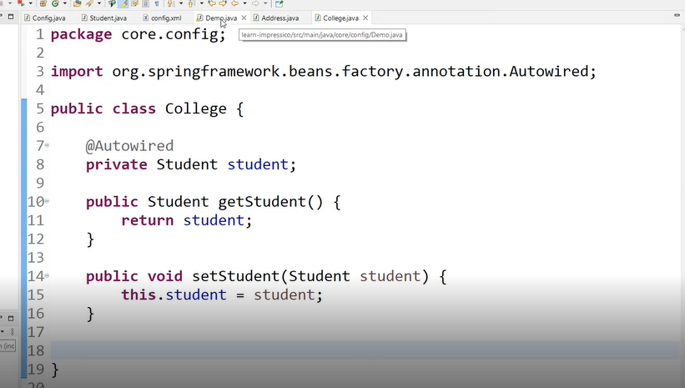

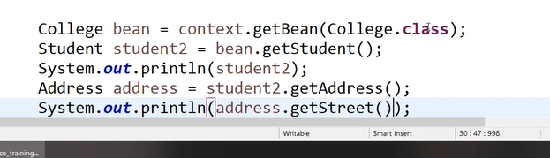

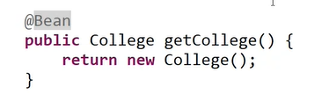

Multi injection is happening

Student is injected in college

And address is injected in student

1. So if we notice -> @bean is only applied on methods
2. So if we dont want to make all these objects in the config file

And create the bean in the class itself

We use @Component annotation

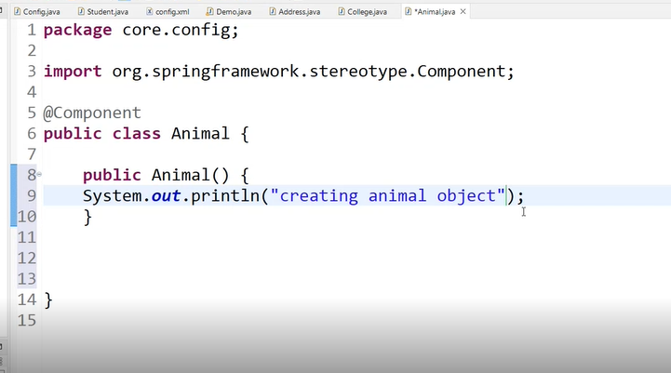

But we have to specify the package where we r using this annotation in the config file

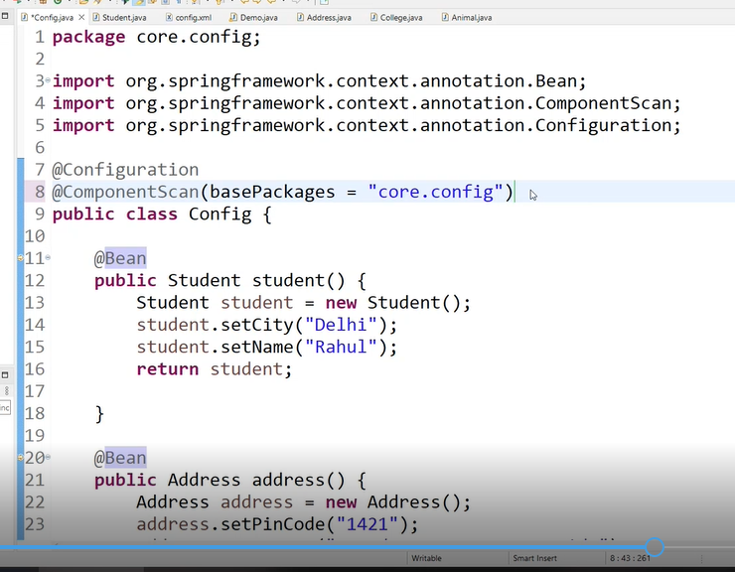

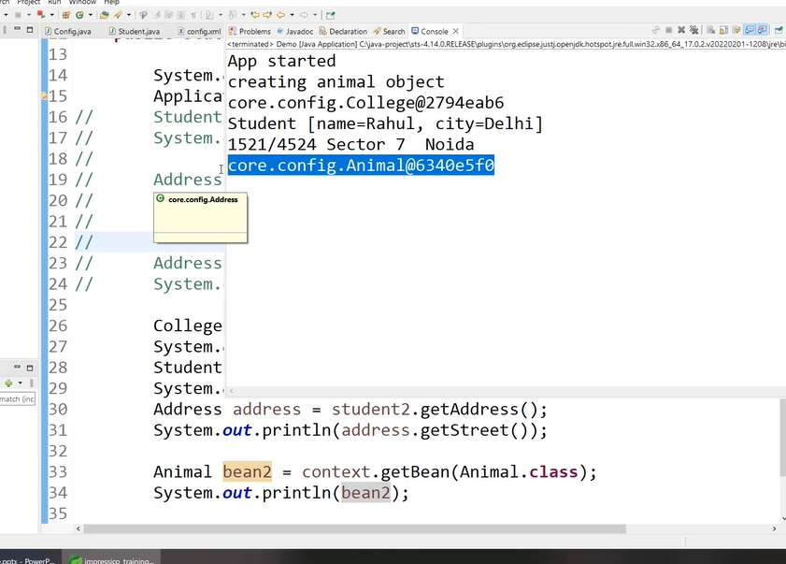

So bean is created automatically

1. So to access bean of classes in diff packages we also have to specify them in config file



1. We can also name the bean

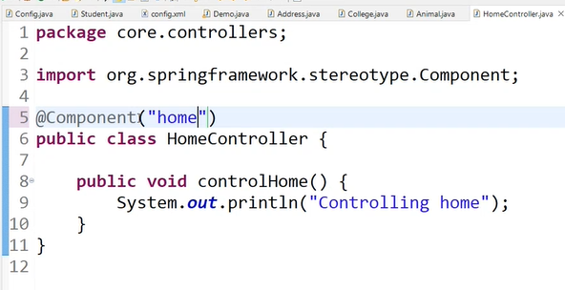

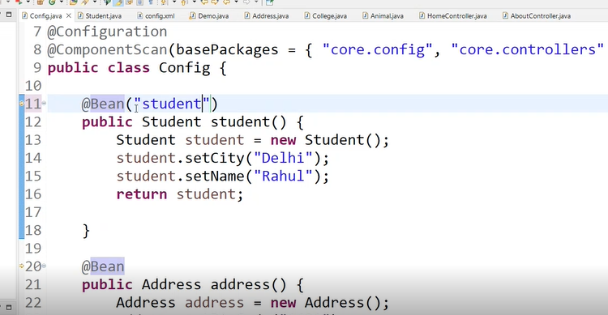

We can use the this name to access the bean

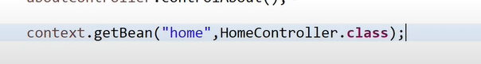

1. LIFECYCLE OF A BEAN

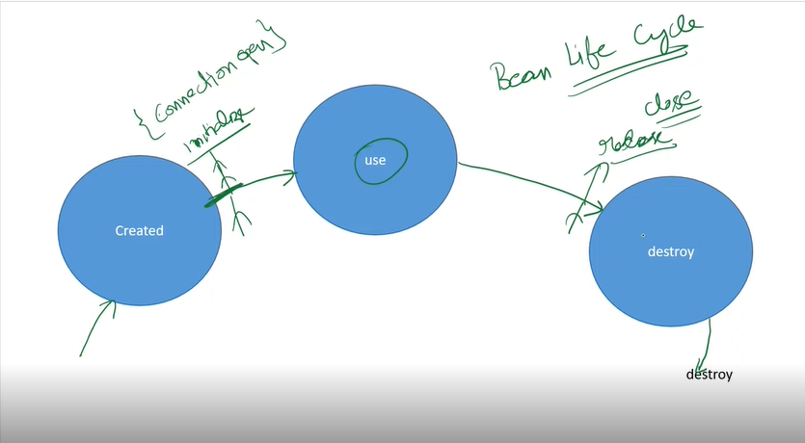

WE USE TWO ANNOTATIONS

POSTCONSTRUCT

PREDESTROY

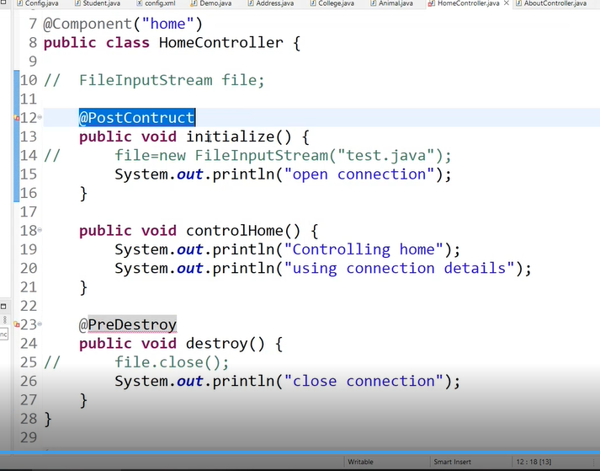

We have to add this dependency to use this

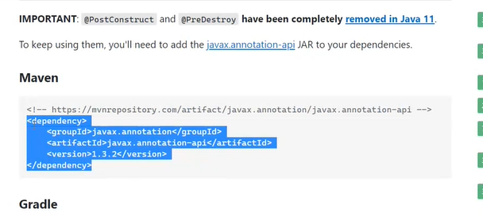

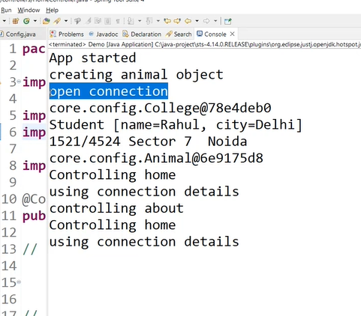

# 7TH NOV

## LEFT OF 1hr 22min

# ASSIGNMENT 1

1.jdbc bean

jdbc dependency

PASS OBJ OF DATASOURCE

Datasource has these

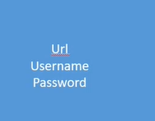

Jdbc uding datasource

Service using jdbc

Autowire everything

2. JPA

ORM CONFIGURATIONS

# HIBERNATE ASSIGNMENT

STEPS

1. Create bean of DriverManagerDataSource which is an implementation of the interface DataSource

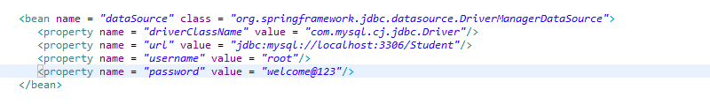

1. Create a bean of LocalSessionBeanFactory

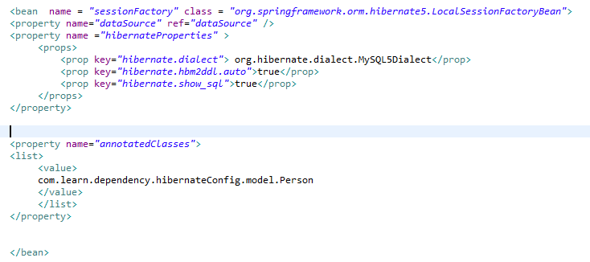

So we r passing datasource obj here

And rest r just some hibernate properties

After that we are using annotatedClasses which also comes with hibernate in which we are just giving the location of our model file

1. Bean of hibernate Template



1. Create PersonDao

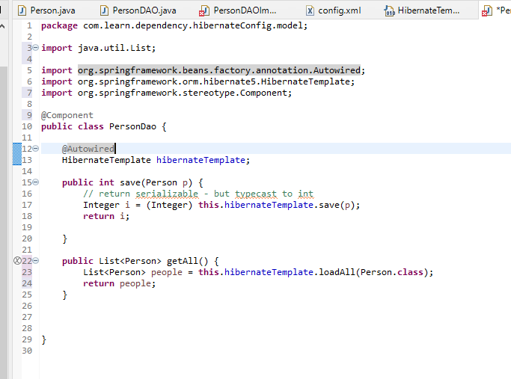

# 9TH NOV

## Jdbc demo - jatin

Spring - manual dependency management - prb

* Manual configuration

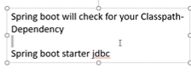

Springboot enables auto configuration

Also manages dependencies ->

Using starter project

Eg -

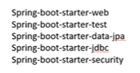

3. Making spring boot prj

Open sts



We have to map our url to our methods - @requestMapping

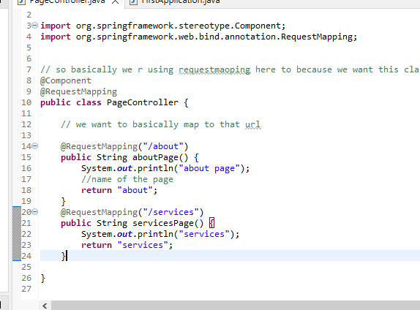

Create the web pages in

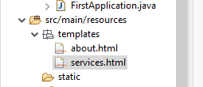

@Controller does the work of both @Component and @RequestMapping

Problem with controller is when we are returning like

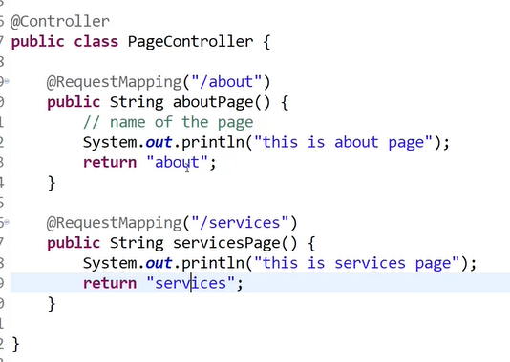

So this has to be a view or page

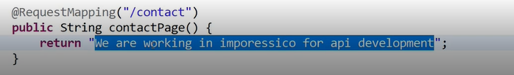

This will give an error because it wont be able to find it in template

So for that we have to use the annotation @ResponseBody

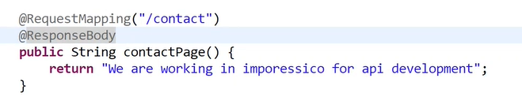

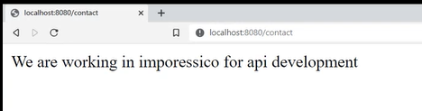

### Lets say we have separate classes for mapping returning pages and other returning texts

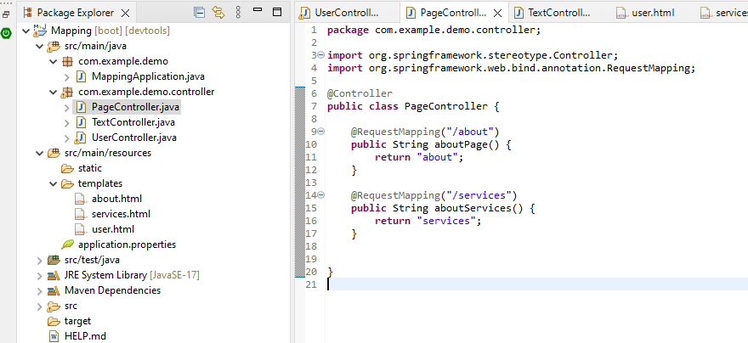

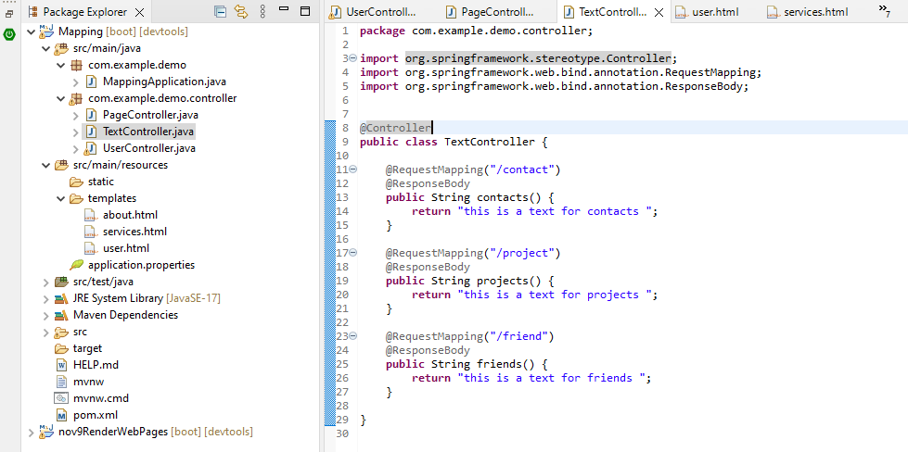

But as we can see its getting very repetitive - we can remove @ResponseBody

And instead of it we can use @RestController

We use it when we know we have to send text directly as a response - called RestAPIs

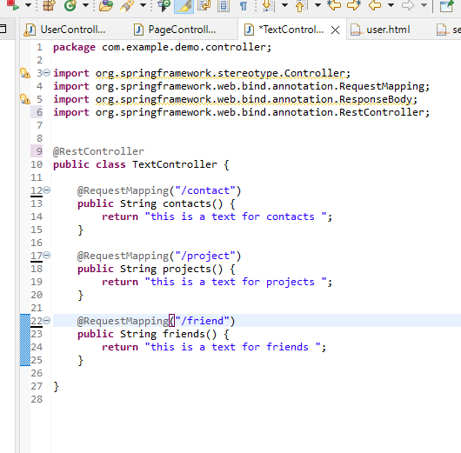

### summarize

@Controller -> when we have to send a page

@RestController -> when we have to send text directly

@RequestMapping -> map url to the handler

For @RestController its not just limited to text we can return diff objects

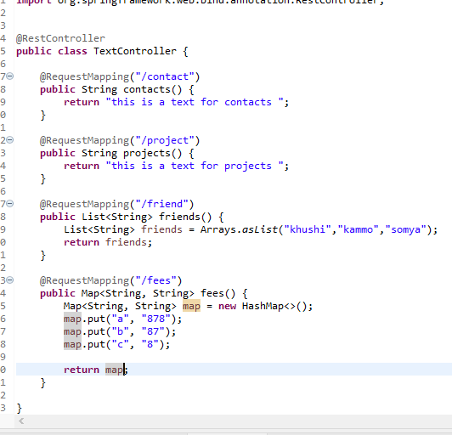

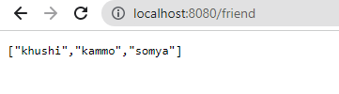

Here what is happening is we r making a java list but as we see in the result its returning as a json obj - this is done by spring

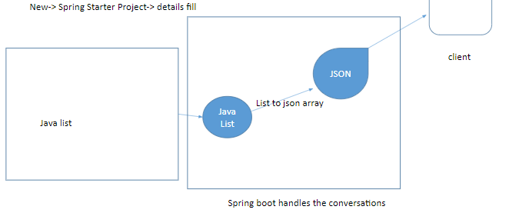

Is done by Jackson library which is automatically downloaded when we use spring web dependency

4.

So instead of just using java collection - map, list etc

Lets define our own datatype -> student

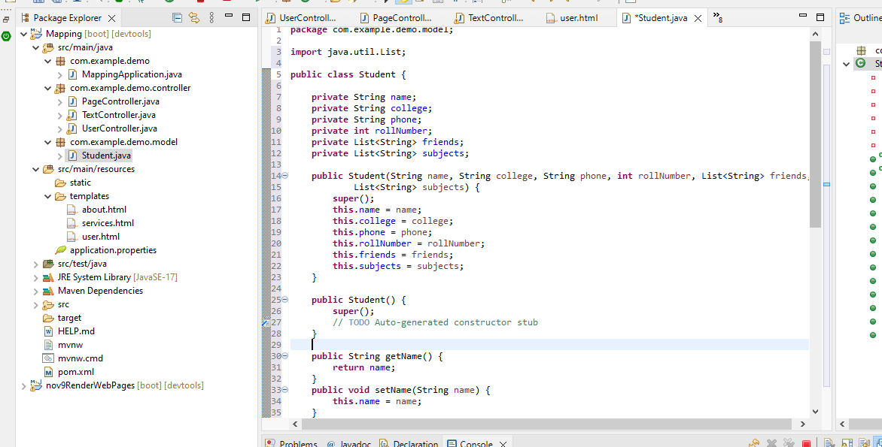

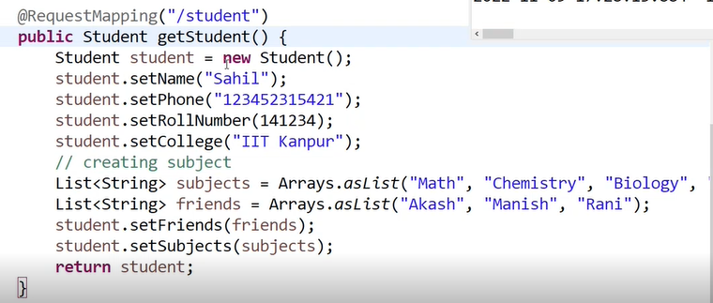

5.

@SpringBootApplication - combination of a lot of annotation

It also has componentScan which scans the its own package by default

In this prj my controller wasnt working

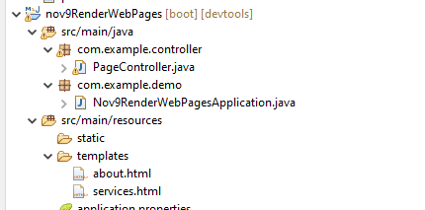

Because in main class the path is package com.example.demo;

so its doing component scan for this path only

and I made my controller in package com.example.controller;

instead of package com.example.demo.controller;

That's why it isn't working

# 10th nov

## Hibernate doubt clear up - deepak

## Client has to send data

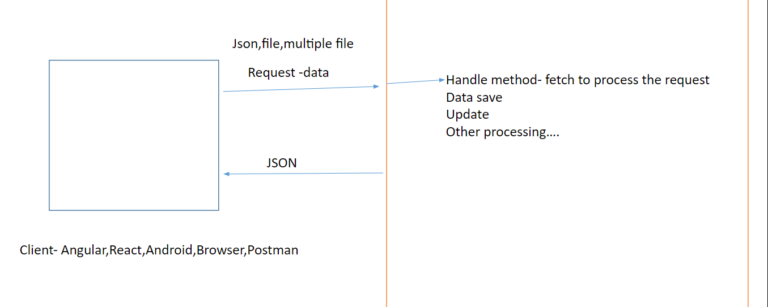

## Receiving json obj

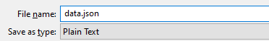

Making a json file

**Json obj** is same to javascript obj

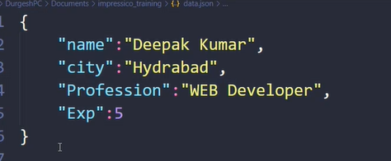

**Json Array**



We can have complex data

Like here we have an array as obj as it also has obj inside it

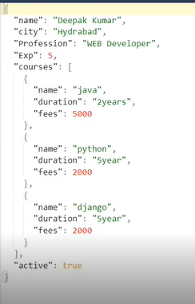

## To send json as a client

We have two ways

* Request body
* Form data

Through request body - postman

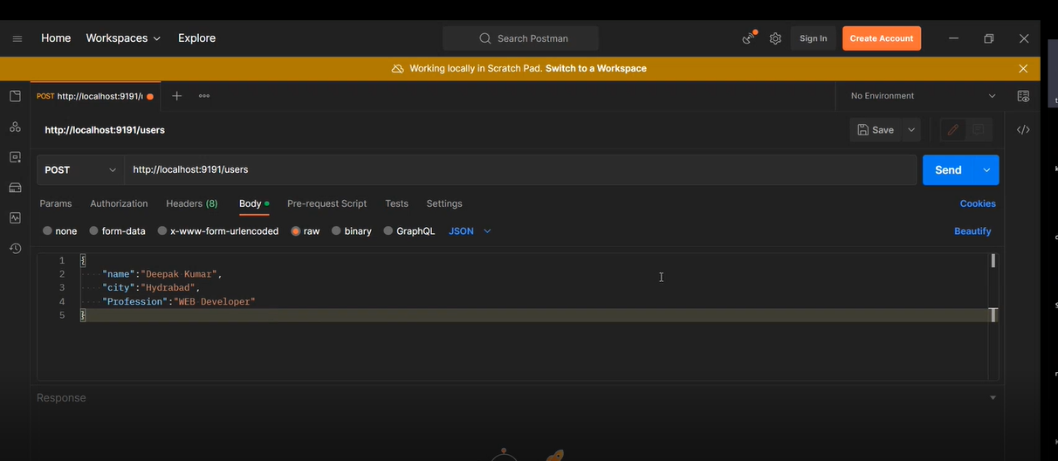

To accept on the server ->

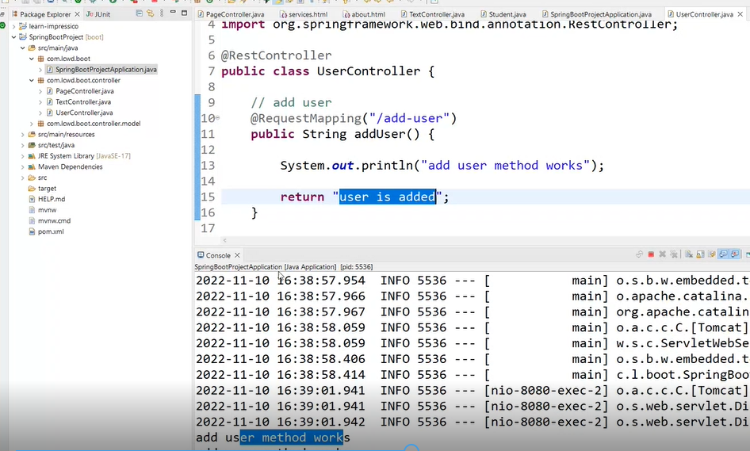

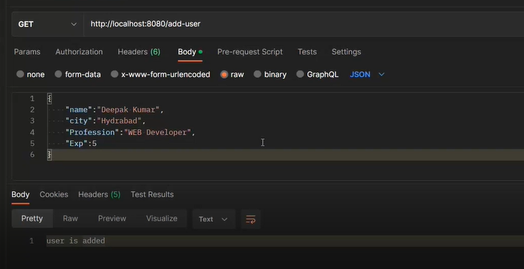

So its working

To receive the data



What requestBody does is convert whatever json obj it gets to a java obj and deserialize it

**Serialization is the process of converting an object into a stream of bytes to store the object or transmit it to memory, a database, or a file**.

SO converting Json obj to Java obj is called deserialization

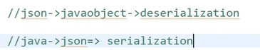

As its a key-value pair thats why we r using map

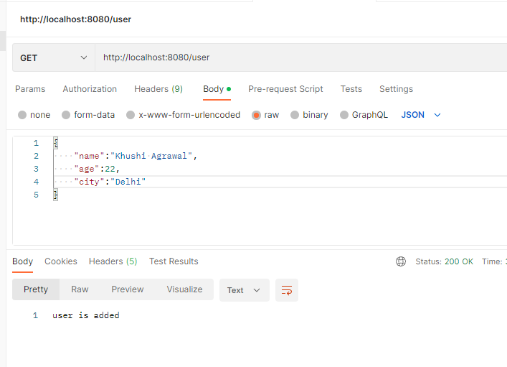

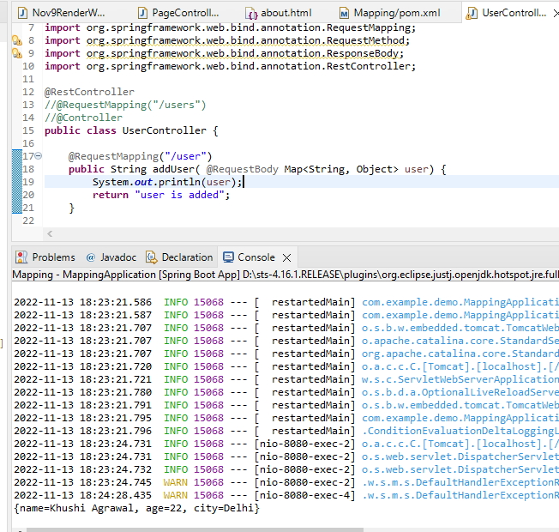

## So we have the type according to the data we r receiving

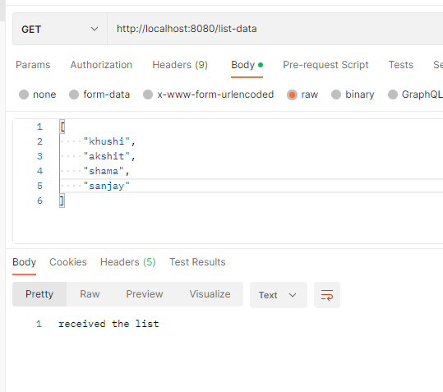

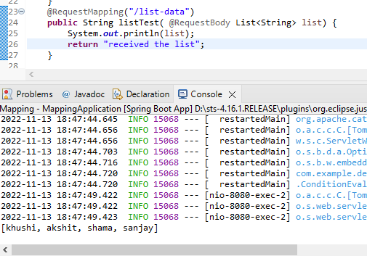

So basically we have to focus on finding the type of expected type of data

## Till now we were using predefined types

Lets say we have created this one datatype User

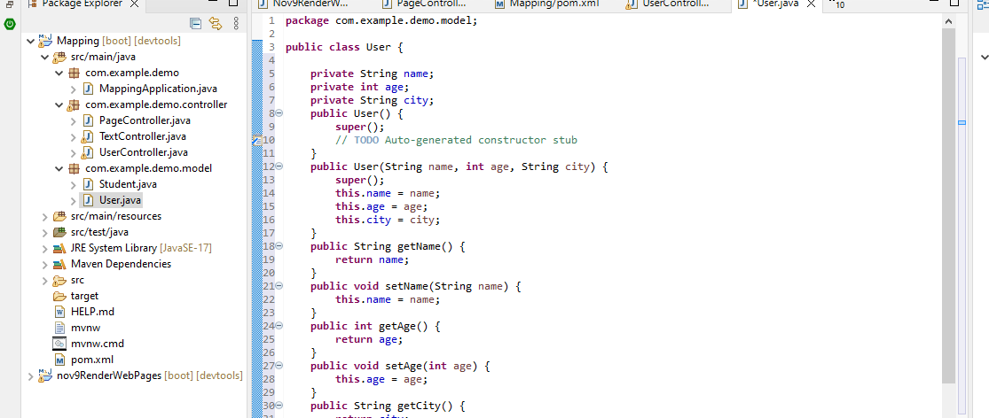

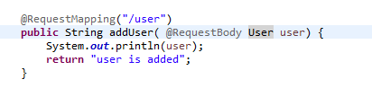

we get this user object

So now when it deserializes the data it will automatically map the values to different variables

Adding this method in user

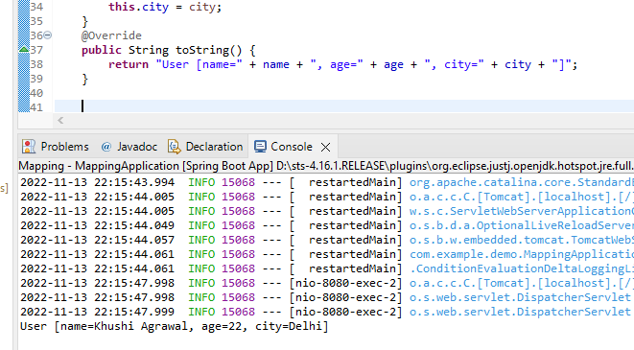

So if by chance if their is a key mismatch it assigns it null value

## Using form data

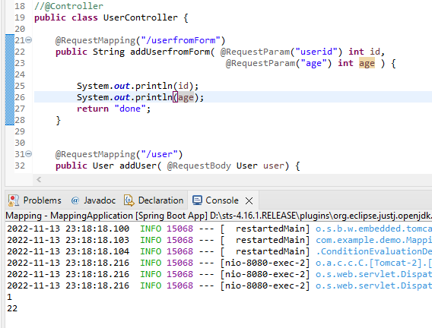

@RequestParam

userId - key

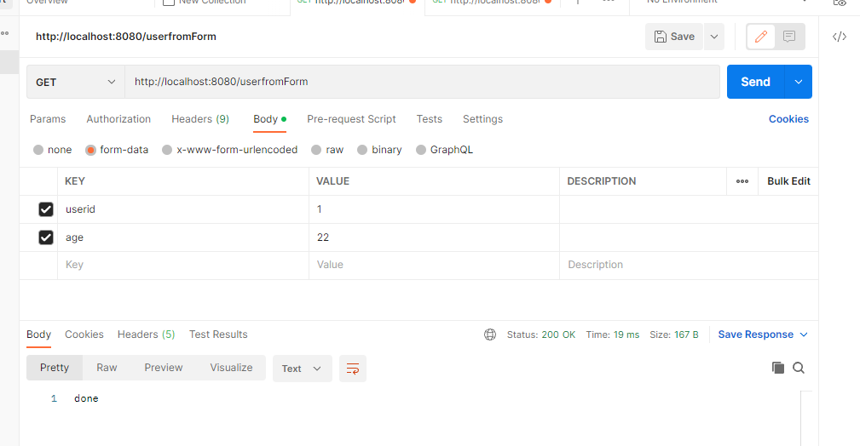

If the variable name is same as key then no need to write key

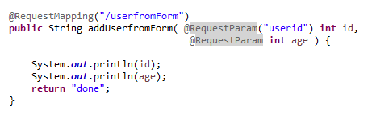

## Data in url

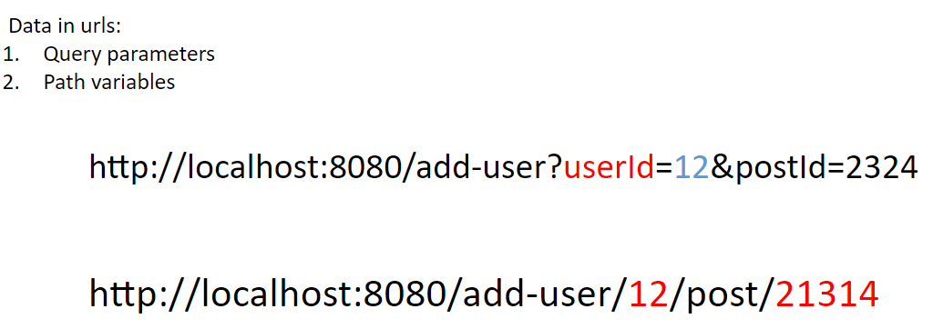

To fetch data

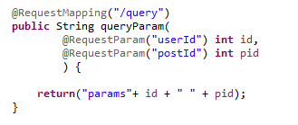

To make postId optional

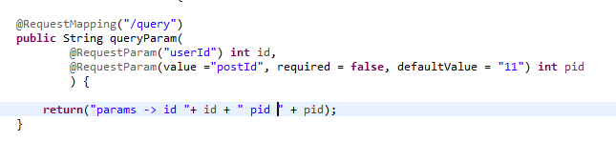

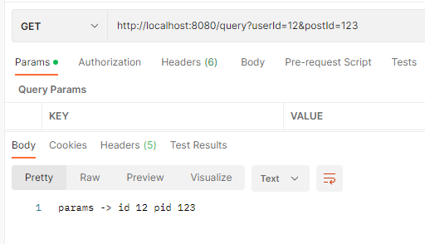

Using path variable

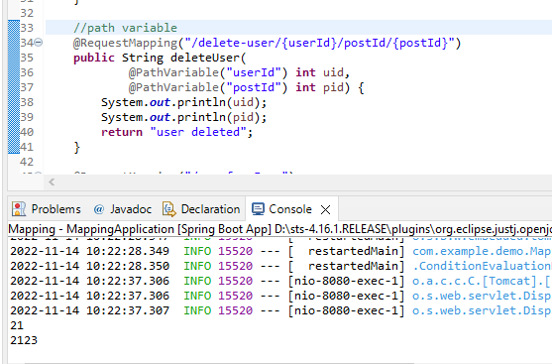

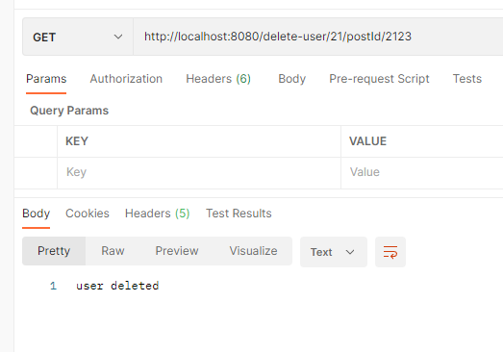

## File as input

Takes it in form of form data

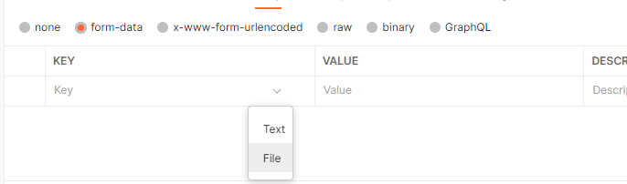

The datatype to store image is multipartFile -> an interface

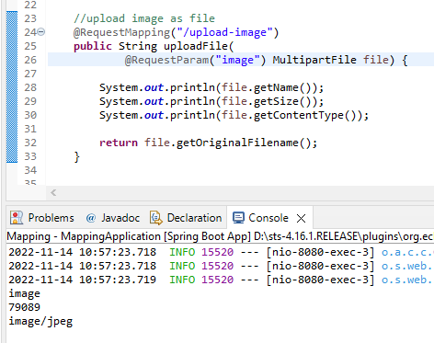

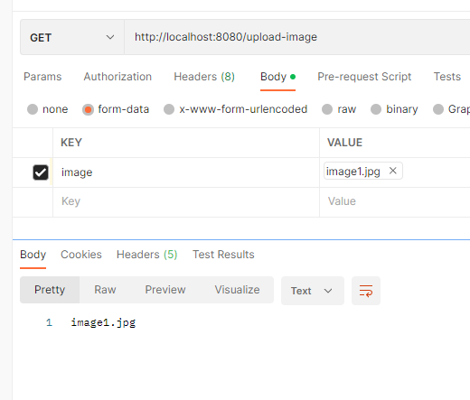

If the file exceeds the size limit then ->

w



We can control the size

When we have to do any configuration of anything -> application.properties

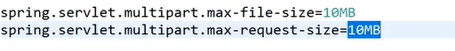

To put up a condition for content type

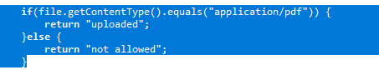

## Send image and text simultaneously

## HTTP METHODS

Use of HTTP protocol - set of rules - used when client is communicating with the server

Hyper Text Transfer Protocol

Request - either using Http method or any protocol

If their is data in response and we r using rest api then it would be json

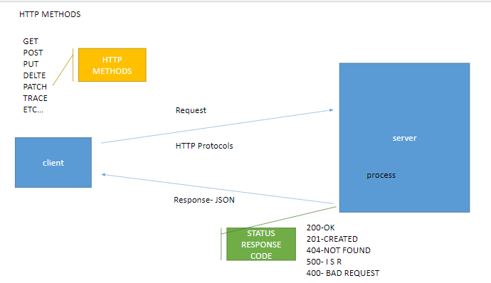

## 

# 11th nov

## Dev tools

## Application.properties

Contains main configuration of the prj - i.e. like for server, database, file etc

Maintains a key-value pair

Prb -> when we have to manage these configurations for diff environments - dev/ testing/production etc

We will make diff properties file for diff environments

Application.properties run for every one

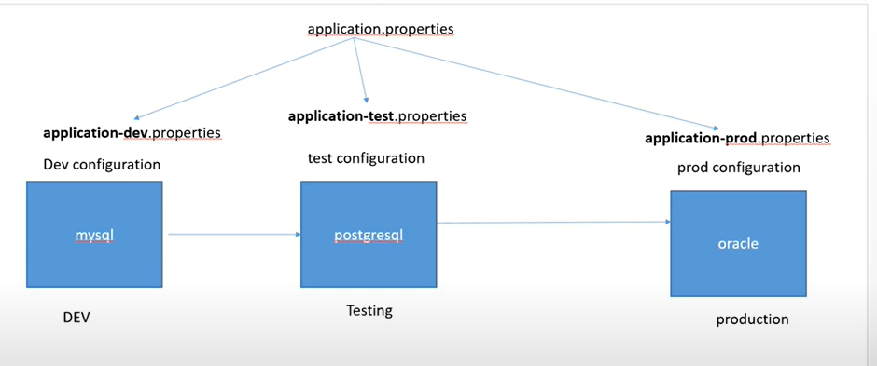

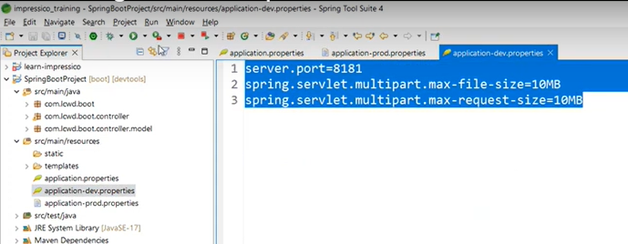

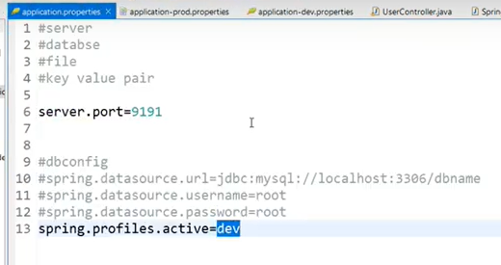

Can also change in runtime

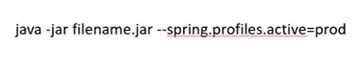

One more prb is that there is too much repetition of prefix of keys

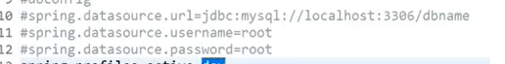

To solve this we can create a yml file

Application.yml

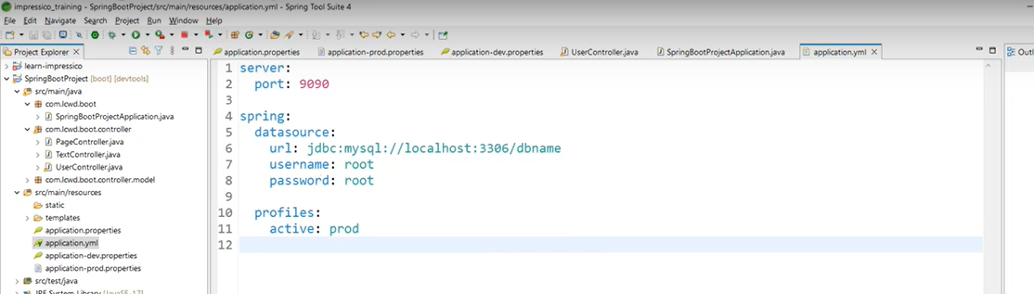

### mapping and http methods

We can specify out methods with url as well

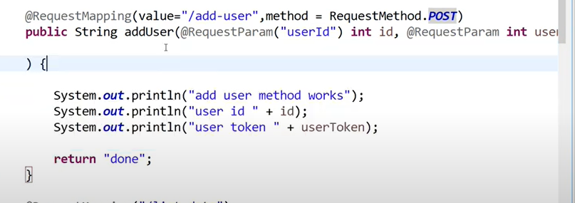

Or

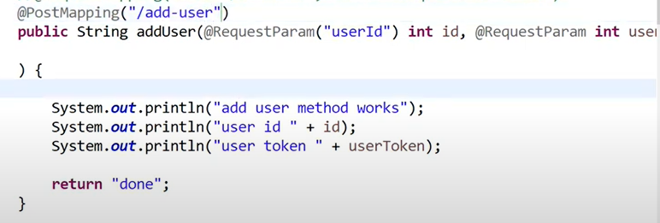

So if we want to use @PostMapping with the @Controller then we would have to provide @Response Body to send data to the view/page

Same way for get method and all other

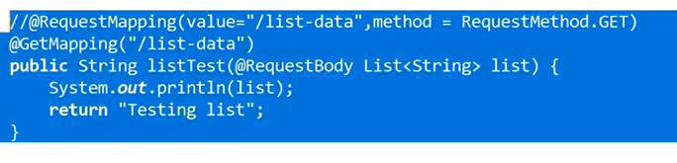

## Response Status code

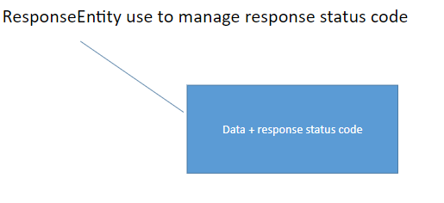

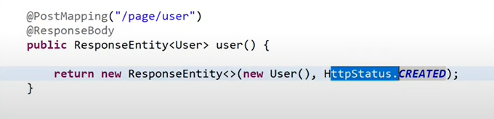

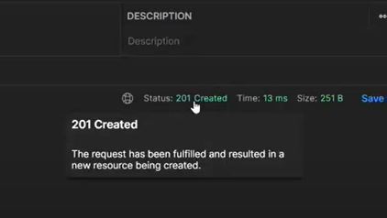

Different ways

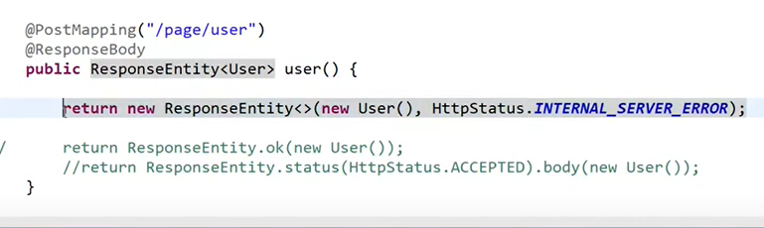

# 14th nov

# Mystore prj - whimsical dia

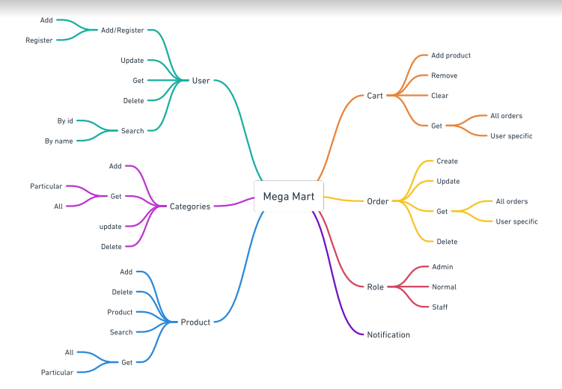

# Architecture

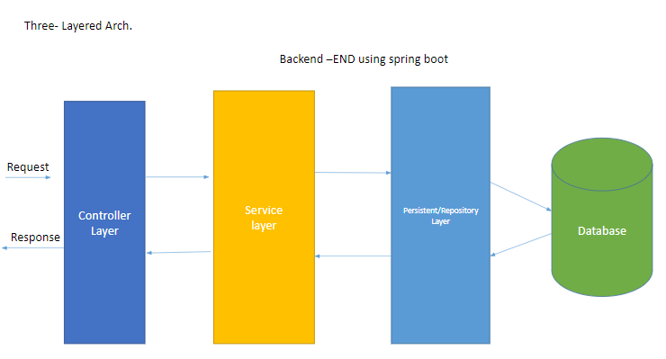

Controller layer -> classes that accept the response

Service layer -> classes that process the logic

Persistent layer -> classes performing db operations / DAO

## Code

3.1 made some packages

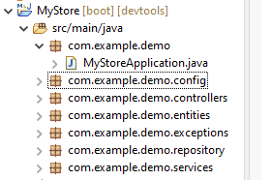

3.2 Starting with User entity

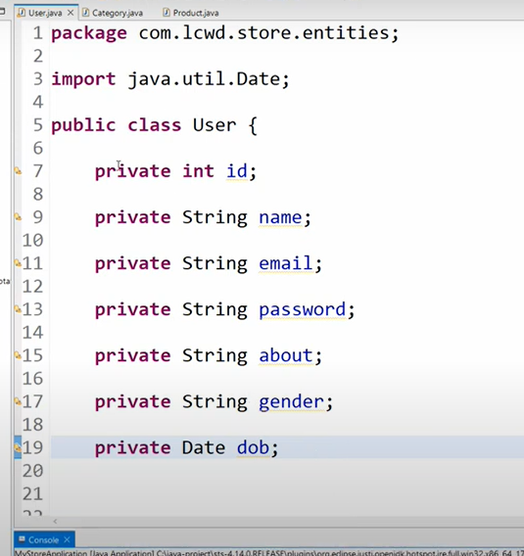

Using lombok we can create getter and setters and much more

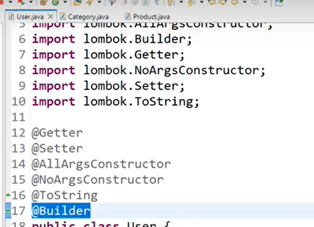

It also gives a builder annotation which

<https://projectlombok.org/features/Builder>

So instead of accessing the class by making its obj like we would have normally done

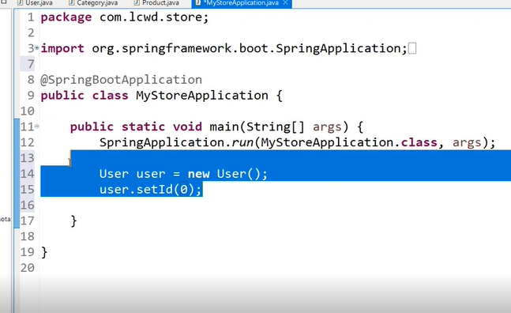

We could do it like this

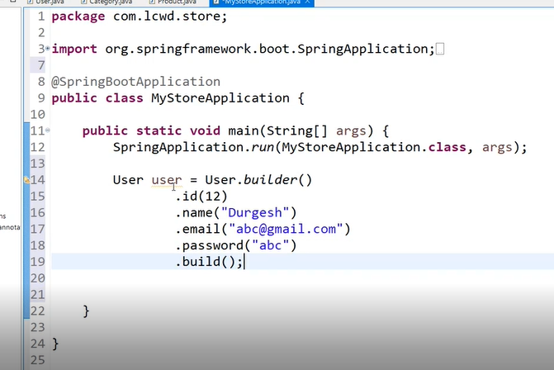

## Configuring lombok

## Service layer - making UserService

This will contain the logic for

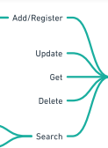 with the user. I.e. searching a user, deleting a user etc

For loose coupling we will make it an interface

So in this we will just specify what to do and not how to do it

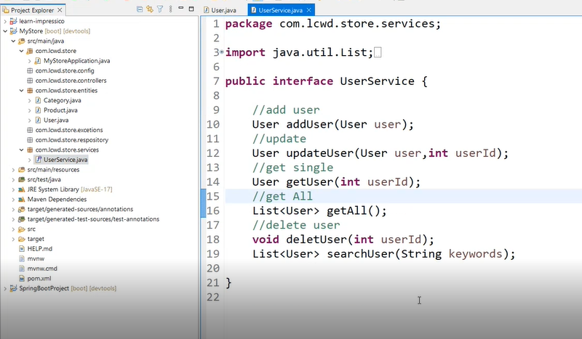

Public and abstract keywords are not necessary to be used in interface as its already implemented like that

So these are the methods and for its implementation we will ->

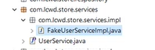

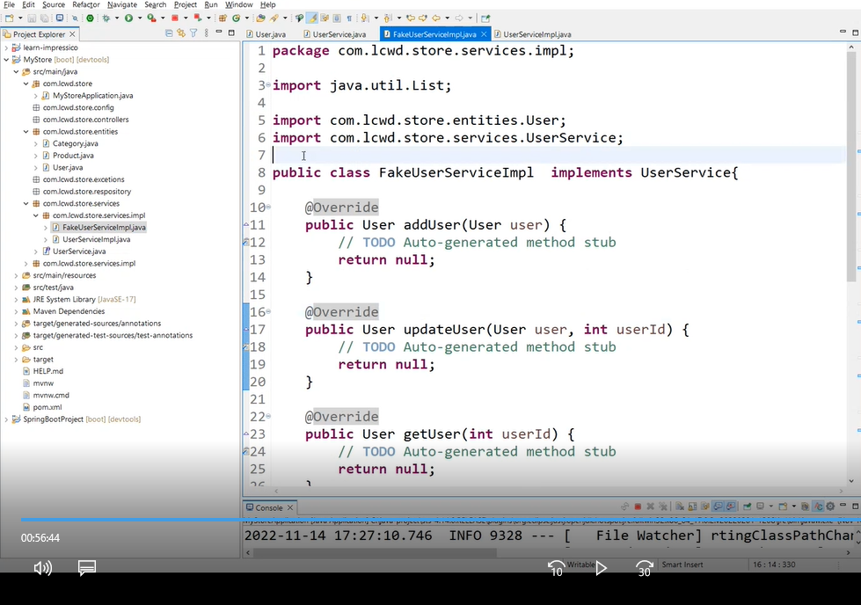

We have implemented all the methods here

Also we have created a UserServiceImpl for the actual implementation of the methods which would be somehow connected with the database

We will use the @Service annotation in both files so that

Spring [@Service](https://www.digitalocean.com/community/users/service) annotation is used with classes that provide some business functionalities. Spring context will autodetect these classes when annotation-based configuration and classpath scanning is used.

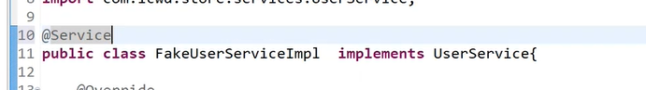

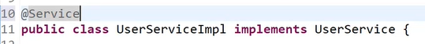

For now until we use database we will be using the FakeUserServiceImpl so we will make it primary

@Primary **indicates that a bean should be given preference when multiple candidates are qualified to autowire a single-valued dependency**.

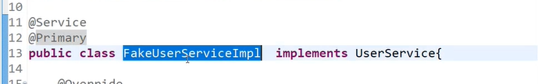

# 

# 15th nov

## DTO, DAO, ENTITY

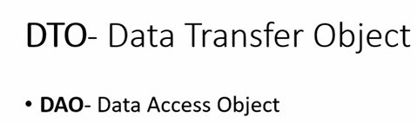

DAO - can interact with the database. Get an obj from db or put an obj in db etc

DTO - used to transfer the data obj. Used for eg when we have to access a data which is in controller in services, so we need kinda like a container to hold the data for us. This container is DTO. from which data can be accessed from. DTO basically helps transfer data from one layer to another.

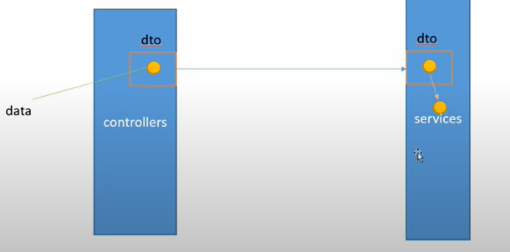

Entities - will be used to connect data with the database. Mapped with database table.

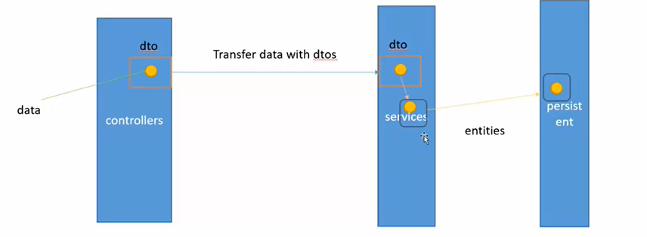



So this user dto will have the same stuff as user entity - its just that this will be used to transfer the data

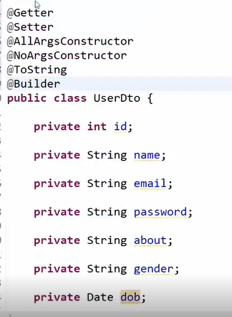

We r making this dto because we want to access it in service layer

So instead of passing the entity in the methods we will be passing the dto as the fig suggests

So we will change that in the service layer. So basically what it will be receiving from controller is dto and the return is also a dto cause we would have to send it to the persittent layer

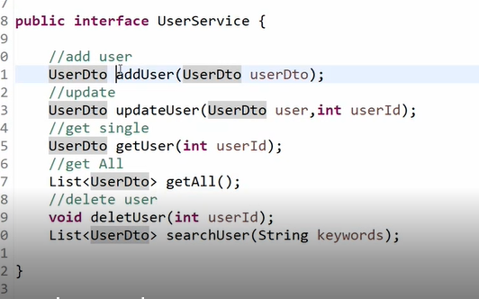

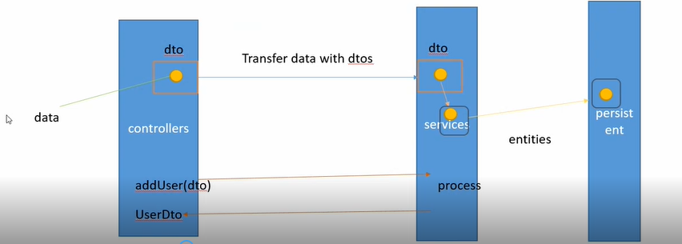

Same way we will change that in userServiceImplementation

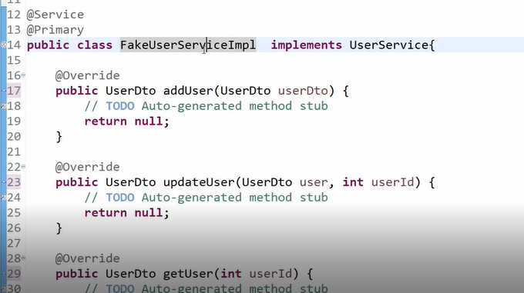

## ModelMapper

As we dont have database connectivity we r just creating a list of users

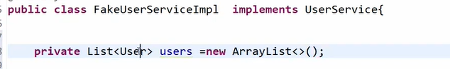

Here we r using entity User rather than dto as we r storing the data

Here we wont be able to pass the dto as our list needs the user entity. So we need to convert the dto to entity.

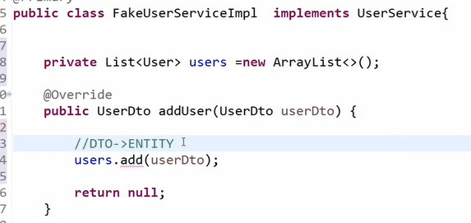

To map the dto with entity we will use ModelMapper

<!-- https://mvnrepository.com/artifact/org.modelmapper/modelmapper -->

<dependency>

<groupId>org.modelmapper</groupId>

<artifactId>modelmapper</artifactId>

<version>3.1.0</version>

</dependency>

In order to use ModelMapper we will need a bean

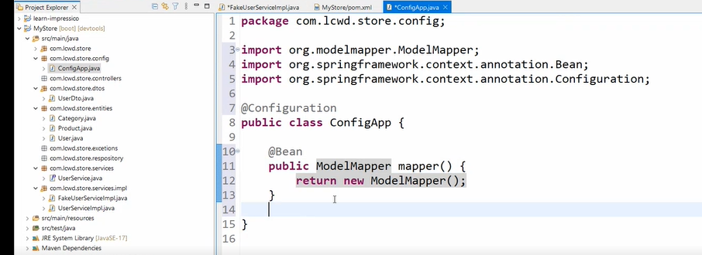

So we created a config file and created a bean of ModelMapper so that it can be autowired

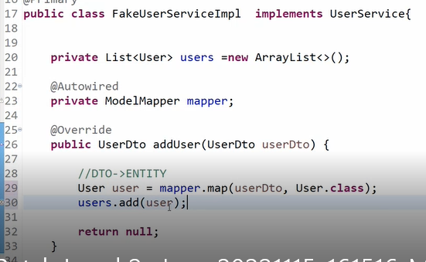

## 3.Logger

Logging in spring boot is basically an API that **provides tracing out of information along with a recording of any critical failure that might occur in the application during its run**

This one and not the other ones



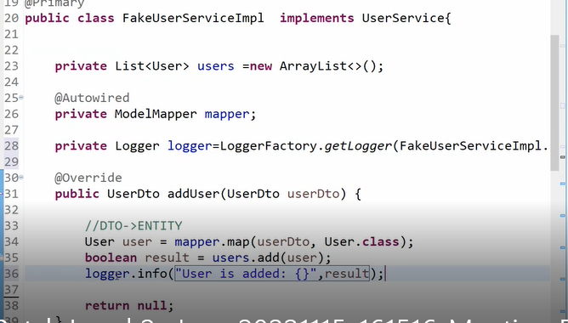

## 4. Making all the methods

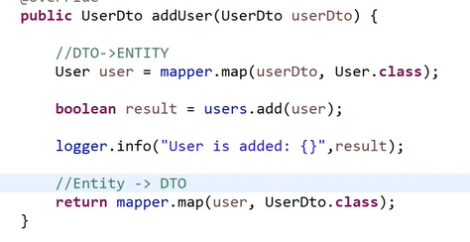

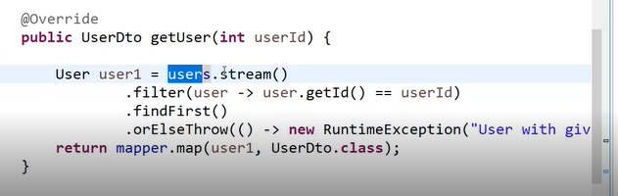

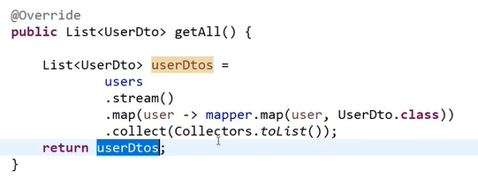

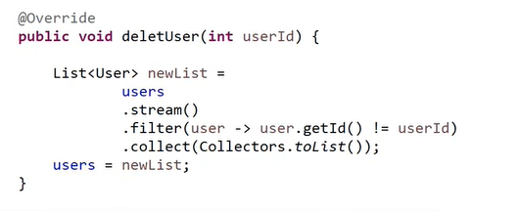

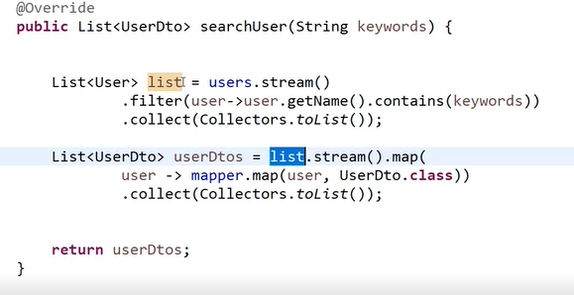

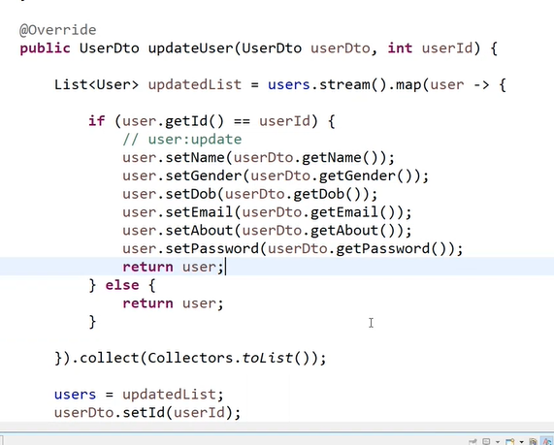

# 

## 5. UserController

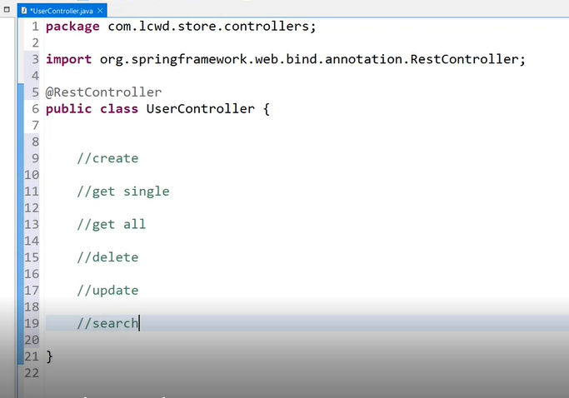

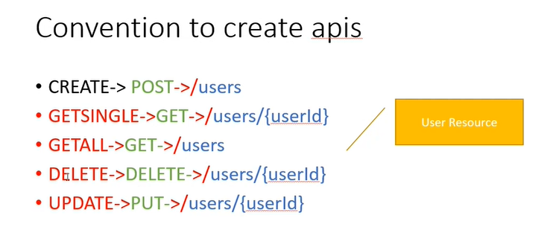

So we need user service to get all the methods of user

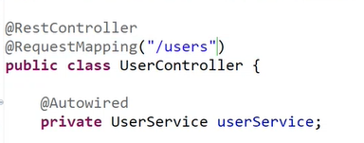

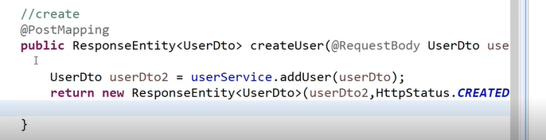

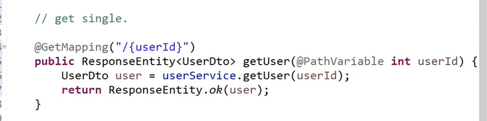

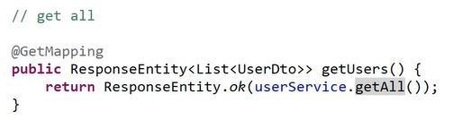

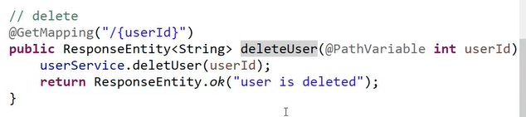

## 6.API response

Its not a good practice to send mssg as string

To send mssg as json

We need to

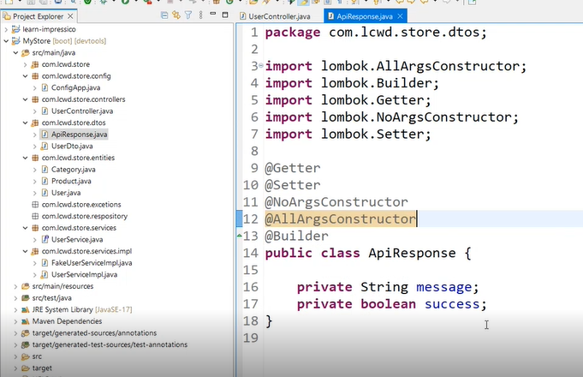

So we change our return type

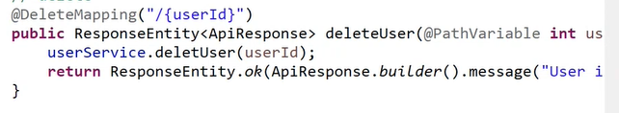



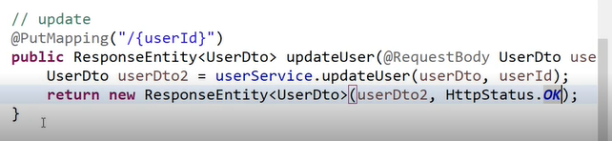

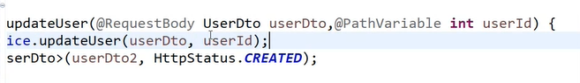

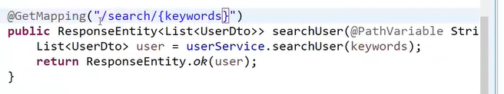

Their r actually two ways to return responseEntity

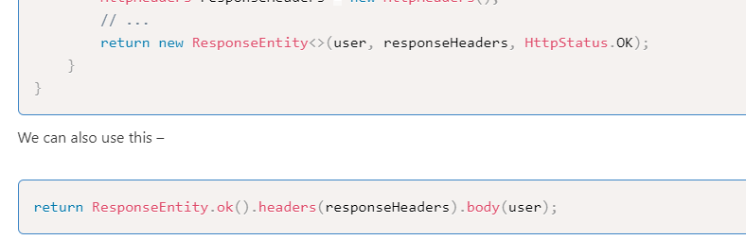

## DONE Left - Assignment - same for categories and product, try for cart

# 17th nov

## Handling exceptions

For huge prjs - try catch not very appropriate

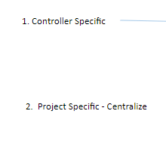

Making controller specific exception ->

@ExceptionHandler

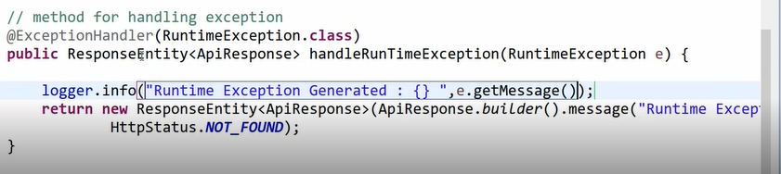



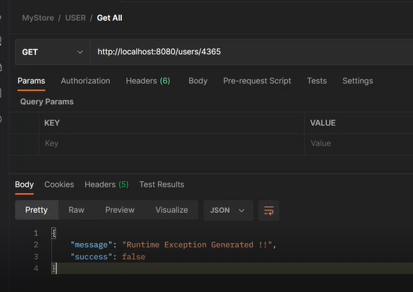

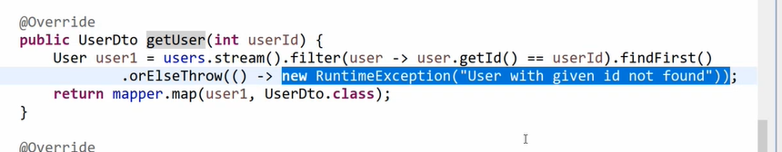

GOOD - scenario specific exception

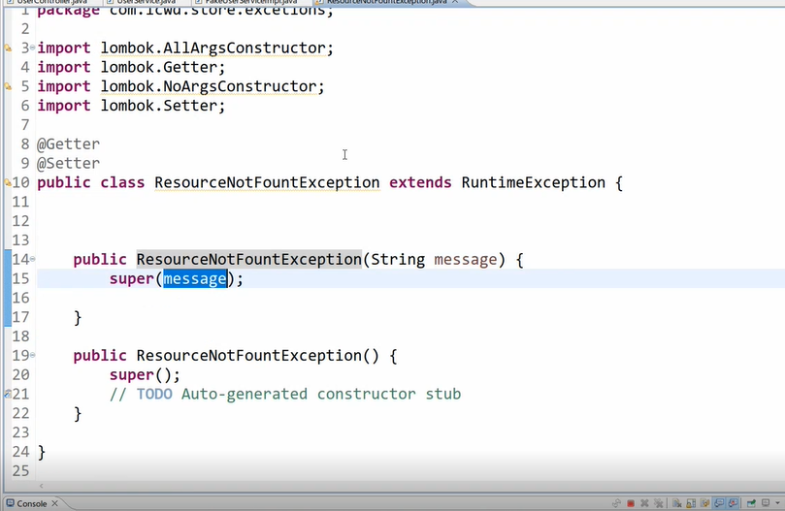

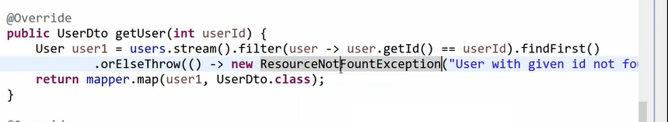

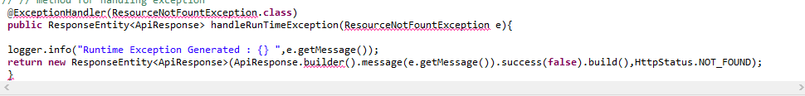

So basically we r making specific exceptions and not using generalized exception

## 1.2 project specific

## Global Exception Handling

### oUsing @ControllerAdvice Classes

A controller advice allows you to use exactly the same exception handling techniques but apply them across the whole application, not just to an individual controller.

Any class annotated with @ControllerAdvice becomes a controller-advice and three types of method are supported:

* Exception handling methods annotated with @ExceptionHandler.
* Model enhancement methods (for adding additional data to the model) annotated with  
  @ModelAttribute. Note that these attributes are *not* available to the exception handling views.
* Binder initialization methods (used for configuring form-handling) annotated with  
  @InitBinder.

@RestControllerAdvice = @ControllerAdvice + @ResponseBody.

Keeping in mind that @RestControllerAdvice is more convenient annotation for handling Exception with RestfulApi.

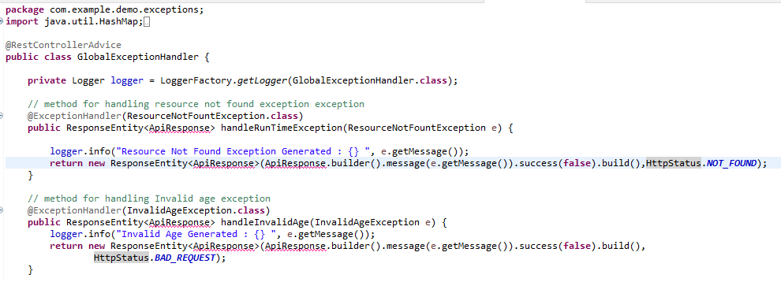

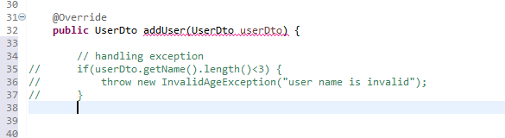

## Validate the request data

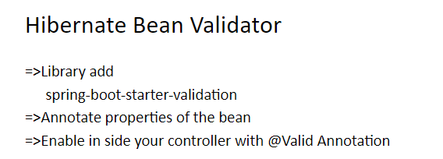

We will be using a library - hibernate validator or bean validator

We will do validity when the obj serialize i.e changes from obj to json

I.e we will validate before bean would be created

So if it doesnot fulfill these validations it will raise exceptions

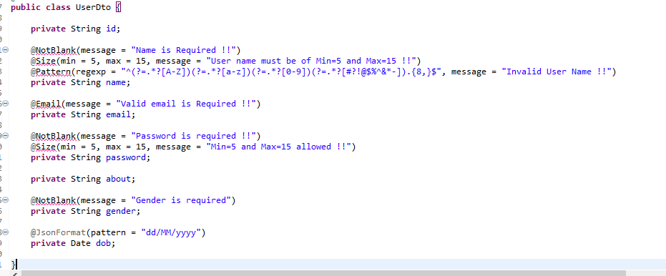

These messages will be used in exception if the validation is not fulfilled

Regex

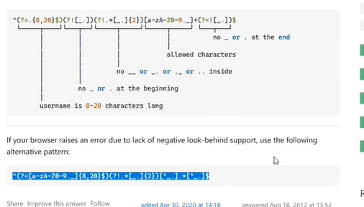

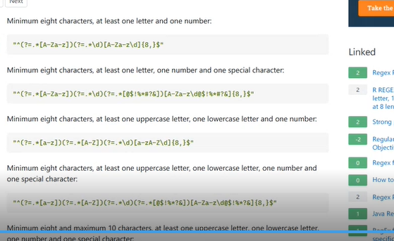

In order to start this validation we need to enable it in the controller with @Valid annotation

So inside the usercontroller we have used it where we r creating a bean that our create User func ->

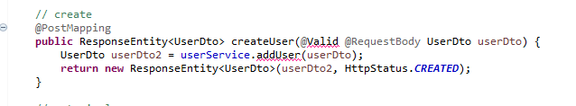

## Left - assignment -3 -> validate date obj

